Super Apple Problems!!! Or something like that…worksheet
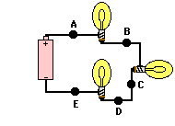

- Please diagram the circuit above using the standard symbols. Which way is the current flowing?

- If a circuit is set up where a resistance of 45 Ohms, is placed across a voltage of 8 V, what is the current?

- Using your answer from question 2, what is the power (the rate at which energy is transferred)?

- A lamp draws a current of .50 A when it is connected to a 120 V source. What is the resistance of the lamp? What is the power consumption of the lamp?

- A 75 W lamp is connected to 125 V. What is the current through the lamp?

- A resistance of 23 Ohms is placed across a voltage of 34 V. The current is 3 A. Does this obey Ohm’s Law?

