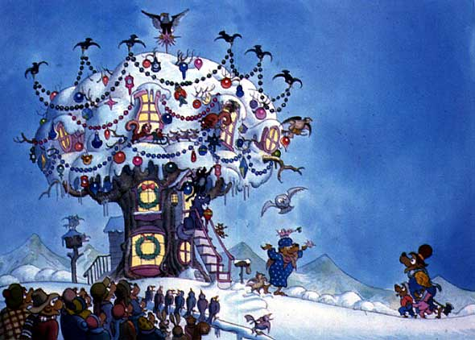

The Berenstain Bears’ Christmas Tree Activities
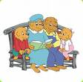
Draw Your Favorite Holiday Decorations!!!

- Create, or draw your favorite holiday decorations. You can create/draw anything from
Christmas trees, to holiday decorations of your choice.

- What is your favorite holiday and why?

Create Your Own Holiday Poem or Rhyme!!!

- Following the rhyming theme of the book, create your own holiday rhyme or poem

- Try to use at least two rhymes, and think about your favorite holiday experience.

- If you are unable to think of a rhyme, tell a story about your favorite holiday.

Outdoor Activity!!! What Kind of Animals Live Near You?

- The Berenstain Bears encountered many different types of animals that live in trees.

- What kinds of animals can you find that live in the trees around you?

- What kinds of animals can you find that live near you?

- What other kinds of animals live in trees?

- What is your favorite animal that lives in a tree?

