Homework Assignments for Earth Science
Marc Daniels

P and S wave Assignment
This is an assignment to get students familiar with P and S waves. The assignment will require them to locate and determine which wave is the P-wave and which is the S-wave. They will also be required to determine the P-S time interval, and whether or not if the wave is a compression or dilation based on the first motion of the P-wave.

Group Mini Project
This will take place during the last lecture/lesson, in which after watching clips about the hazards due to earthquakes, students will be given the opportunity to discuss the hazards seen, possible hazards, as well as create their own evacuation plan for people living in the area. Students will be given about 2 to 3 days to formulate their ideas, and will give a short presentation of them for the class.

Historical Earthquake Short Essay
This assignment will allow students to do research on an earthquake of their choice. They will be required to discuss where the earthquake occurred, the damages due to the earthquake, as well as the time at which the earthquake occurred. They will also be asked why they chose their particular earthquake to research. Since not all students may have the resources to research about an earthquake, 2 to 3 days will be spent in the library of the school.

Earth Science

Name:

P and S waves
(A ruler that measures in centimeters is required)

Steps:
- Locate and label the P-wave and the S-wave.
- Using a centimeter as an interval of 10 seconds, find the P-S time interval.
- Based on the first motion of the P-wave, determine if the wave is compression or dilation.

1)
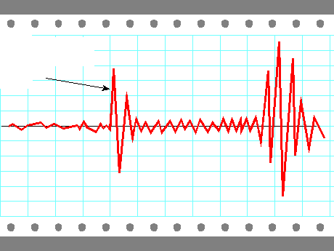

2)
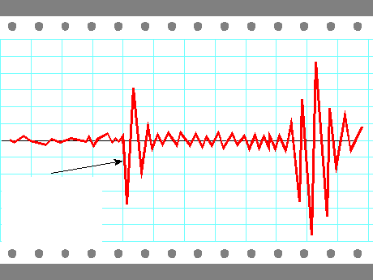

3)
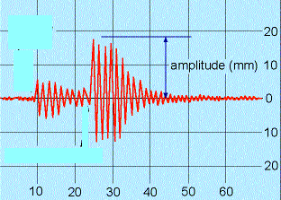

Earth Science

- Group Mini Project
  - After watching clips about the hazards due to earthquakes, what are the hazards seen, and possible hazards? Using your knowledge of hazards and damages due to earthquakes, design your own evacuation plan. This will be due in 3 days, and it will be presented for the class. Either your evacuation plan can be drawn and put in a presentable manner, or you can write a brief paper explaining your evacuation plan, in which you will present a summary of your paper for the class.

- Taking two of the clips, design a possible evacuation plan for the people living in the area.

- Include the hazards that are present, and ways to possibly avoid or prevent those hazards

Earth Science:

Historical Earthquake Short Essay

In this assignment you will do research on an earthquake of your choice. You will be required to discuss where the earthquake occurred, the damages due to the earthquake, as well as the time (year) at which the earthquake occurred. You will also be asked to explain why you chose your particular earthquake to research. (Research and work will be done in the library)

Earth Science
Handout from http://www.geology.enr.state.nc.us/Geologic_hazards_earthquakes/Modified-Mercalli-Scale-Ill.gif

Use just to think of possible hazards for the earthquake chosen in your mini-project as well as your research paper
